Day : Strings (7-8-2025)

1. Find the length of a string without using strlen()
IPO (Input - Process - Output):
Input: A string
Process: Count characters manually using loop
Output: Length of the string
Code:
#include <stdio.h>
int main() {
char str[100];
int i = 0;
printf("Enter a string: ");
gets(str);
while (str[i] != '\0') {
i++;
}
printf("Length of the string is: %d", i);
return 0;
}
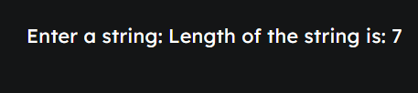

2. Copy one string to another
IPO (Input - Process - Output):
Input: A source string
Process: Copy each character to destination string
Output: Copied string
Code:
#include <stdio.h>
int main() {
char src[100], dest[100];
int i;
printf("Enter a string: ");
gets(src);
for (i = 0; src[i] != '\0'; i++) {
dest[i] = src[i];
}
dest[i] = '\0';
printf("Copied string is: %s", dest);
return 0;
}
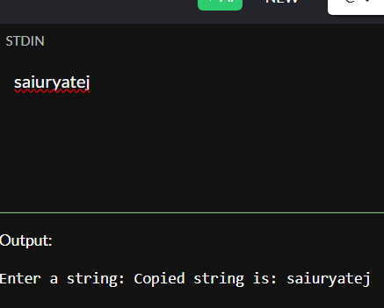

3. Concatenate two strings
IPO (Input - Process - Output):
Input: Two strings
Process: Append second string to first
Output: Concatenated string
Code:
#include <stdio.h>
int main() {
char str1[100], str2[100];
int i = 0, j = 0;
printf("Enter first string: ");
gets(str1);
printf("Enter second string: ");
gets(str2);
while (str1[i] != '\0') i++;
while (str2[j] != '\0') {
str1[i++] = str2[j++];
}
str1[i] = '\0';
printf("Concatenated string is: %s", str1);
return 0;
}
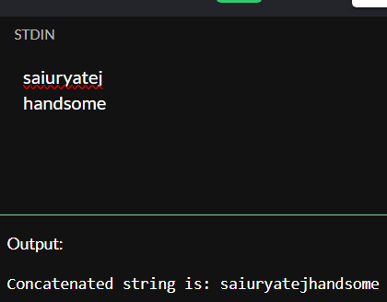

4. Compare two strings
IPO (Input - Process - Output):
Input: Two strings
Process: Compare character by character
Output: Result of comparison
Code:
#include <stdio.h>
int main() {
char str1[100], str2[100];
int i = 0, flag = 0;
printf("Enter first string: ");
gets(str1);
printf("Enter second string: ");
gets(str2);
while (str1[i] != '\0' || str2[i] != '\0') {
if (str1[i] != str2[i]) {
flag = 1;
break;
}
i++;
}
if (flag == 0)
printf("Strings are equal.");
else
printf("Strings are not equal.");
return 0;
}
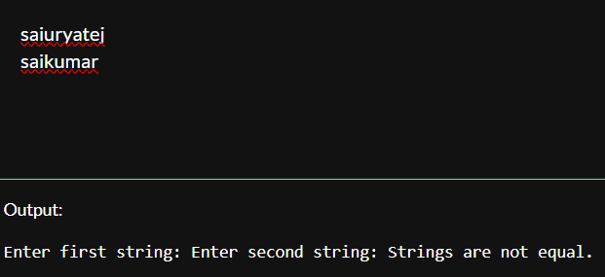

5. Count vowels and consonants in a string
IPO (Input - Process - Output):
Input: A string
Process: Check each character
Output: Number of vowels and consonants
Code:
#include <stdio.h>
int main() {
char str[100];
int i, vowels = 0, consonants = 0;
printf("Enter a string: ");
gets(str);
for (i = 0; str[i] != '\0'; i++) {
if ((str[i] >= 'a' && str[i] <= 'z') || (str[i] >= 'A' && str[i] <= 'Z')) {
char ch = tolower(str[i]);
if (ch == 'a' || ch == 'e' || ch == 'i' || ch == 'o' || ch == 'u')
vowels++;
else
consonants++;
}
}
printf("Vowels: %d\nConsonants: %d", vowels, consonants);
return 0;
}
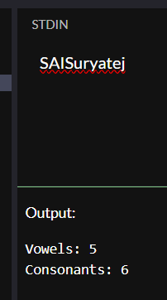

6. Convert lowercase to uppercase and vice versa
IPO (Input - Process - Output):
Input: A string
Process: Convert each lowercase to uppercase and vice versa
Output: Modified string
Code:
#include <stdio.h>
int main() {
char str[100];
int i;
printf("Enter a string: ");
gets(str);
for (i = 0; str[i] != '\0'; i++) {
if (str[i] >= 'a' && str[i] <= 'z')
str[i] = str[i] - 32;
else if (str[i] >= 'A' && str[i] <= 'Z')
str[i] = str[i] + 32;
}
printf("Converted string: %s", str);
return 0;
}
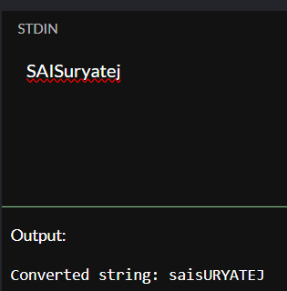

7. Check if a string is palindrome
IPO (Input - Process - Output):
Input: A string
Process: Compare characters from both ends
Output: Whether the string is palindrome or not
Code:
#include <stdio.h>
#include <string.h>
int main() {
char str[100];
int i, len, flag = 1;
printf("Enter a string: ");
gets(str);
len = strlen(str);
for (i = 0; i < len / 2; i++) {
if (str[i] != str[len - i - 1]) {
flag = 0;
break;
}
}
if (flag)
printf("The string is a palindrome.");
else
printf("The string is not a palindrome.");
return 0;
}
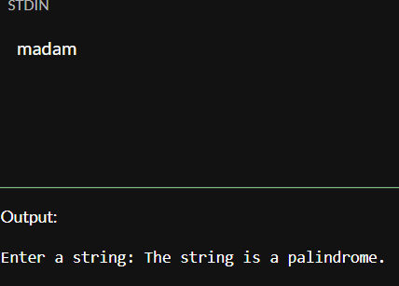

8. Reverse a string
IPO (Input - Process - Output):
Input: A string
Process: Swap characters from both ends
Output: Reversed string
Code:
#include <stdio.h>
#include <string.h>
int main() {
char str[100], temp;
int i, j;
printf("Enter a string: ");
gets(str);
i = 0;
j = strlen(str) - 1;
while (i < j) {
temp = str[i];
str[i] = str[j];
str[j] = temp;
i++;
j--;
}
printf("Reversed string is: %s", str);
return 0;
}
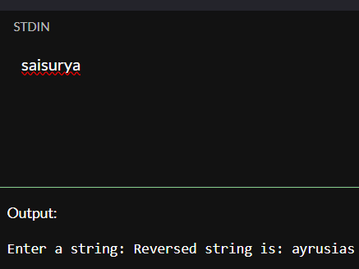

9. Count words in a string
IPO (Input - Process - Output):
Input: A string
Process: Count spaces between words
Output: Number of words
Code:
#include <stdio.h>
int main() {
char str[200];
int i, words = 1;
printf("Enter a string: ");
gets(str);
for (i = 0; str[i] != '\0'; i++) {
if (str[i] == ' ' && str[i + 1] != ' ' && str[i + 1] != '\0')
words++;
}
printf("Number of words: %d", words);
return 0;
}
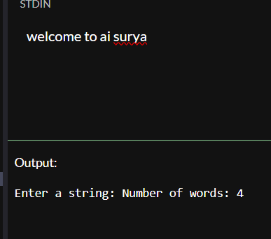

10. Find the frequency of each character in a string
IPO (Input - Process - Output):
Input: A string
Process: Count each character's frequency using array
Output: Frequency of characters
Code:
#include <stdio.h>
#include <string.h>
int main() {
char str[100];
int freq[256] = {0}, i;
printf("Enter a string: ");
gets(str);
for (i = 0; str[i] != '\0'; i++) {
freq[(int)str[i]]++;
}
printf("Character frequencies:\n");
for (i = 0; i < 256; i++) {
if (freq[i] > 0)
printf("%c: %d\n", i, freq[i]);
}
return 0;
}
